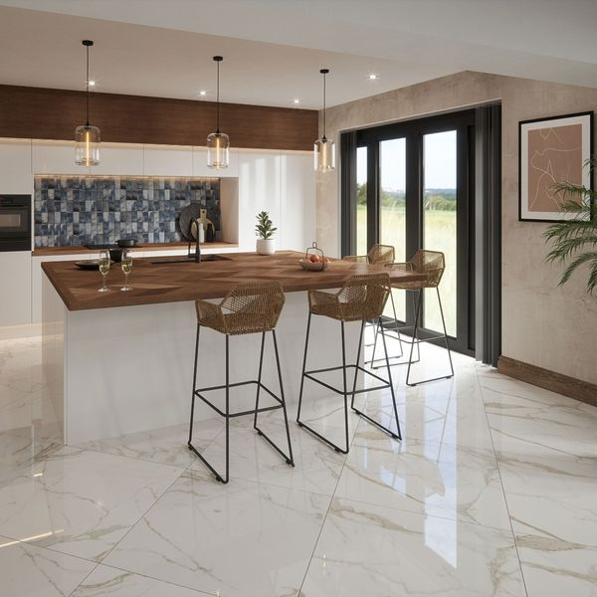**Ruscello Gold Gloss Marble Effect Tiles:**

## **Product DESCRIPTION**

Introduce a luxurious look into your home with our Ruscello Gold Marble Effect Gloss Tiles. Made from durable porcelain, they feature a stunning marble effect design with delicate gold veining, inspired by Italy’s famous Calacatta marble. These tiles create a lavish yet natural feel to any room they’re in, with a shimmering gloss finish that reflects light around the room for a space-enhancing effect.

**What's special about these tiles?**

> Luxurious marble effect design  
> Shimmering gloss finish  
> Organic veining for soft, elegant style  
> Durable, hardwearing porcelain body  
> Perfect for an opulent feel on flooring or walls

## **Product Info**

* Product ID: 44904
* Tiles Per SQM: 2.7777777777778
* Sale by: Per SQM
* Size: 600x600x9.5mm
* Weight: 7.20 KG
* Material Type: Porcelain
* Finish: Gloss
* Colour: White
* Suitability: Floors, Walls
* Grade: 4
* Rectified Edge: No
* Underfloor Heating: Yes
* Thickness (mm): 9.5